Workflow
See changeset 17343 for an example of adding Workflow for an existing document.
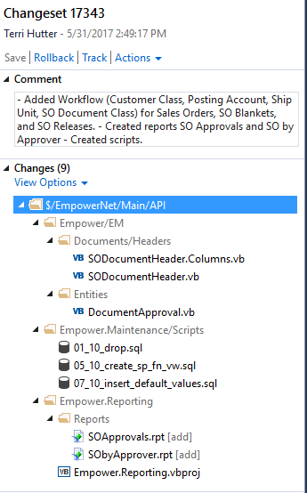

See v2.2.126.0 for examples with entities.
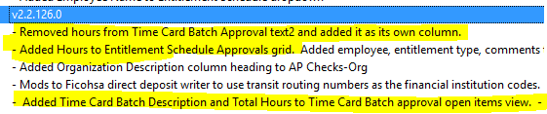
In Empower > EM > Entities > Document Approval, add code to the GetTable function to fill the document.
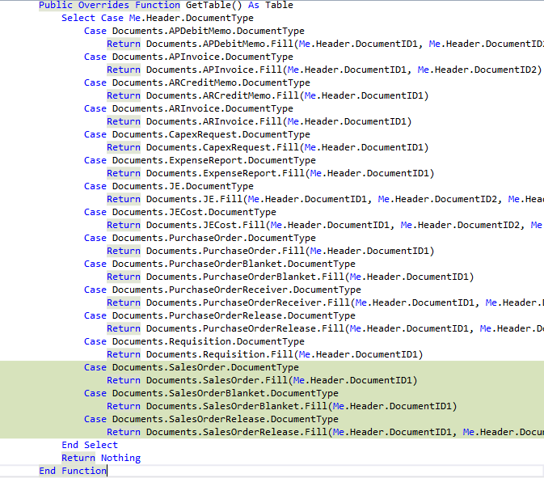

Make sure that all of the columns used to find the approver list are in the header class.
In the case of sales orders, it was necessary to modify Empower > EM > Documents > Headers > SODocumentHeader to include the CustomerClassColumn.

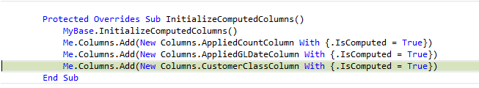
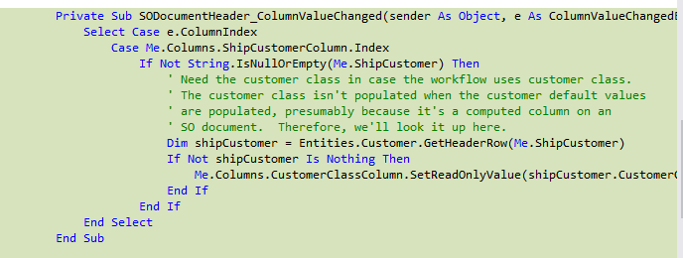

Add the new workflow to default_workflows, giving the workflow a default column_source.
INSERT INTO default_workflows (workflow, column_source, allow_cancel, allow_edit_after_approval, allow_edit_during_approval, sequential, text_column1_label, text_column2_label, inactive, changed_date, changed_user_id, workflow_description, installed_module) VALUES ('SalesOrder', 'PostingAccountColumn', 0, 1, 1, 1, 'Ship Customer', 'Ship Customer Name', 1, GETDATE(), 'SYSTEM', 'Sales Order', 'SO')

INSERT INTO default_workflows (workflow, column_source, allow_cancel, allow_edit_after_approval, allow_edit_during_approval, sequential, text_column1_label, text_column2_label, inactive, changed_date, changed_user_id, workflow_description, installed_module) VALUES ('TimeCardBatch', 'TimeCardGroupColumn', 0, 1, 1, 1, 'Time Card Group Description', '', 1, GETDATE(), 'SYSTEM', 'Time Card Batch', 'PY')

Add the column sources for the new workflow to default_workflow_column_sources.
INSERT INTO default_workflow_column_sources (workflow, column_source, changed_date, changed_user_id, column_source_description) VALUES ('SalesOrder', 'CustomerClassColumn', GETDATE(), 'SYSTEM', 'Customer Class')

INSERT INTO default_workflow_column_sources (workflow, column_source, changed_date, changed_user_id, column_source_description) VALUES ('SalesOrder', 'PostingAccountColumn', GETDATE(), 'SYSTEM', 'Posting Account')

INSERT INTO default_workflow_column_sources (workflow, column_source, changed_date, changed_user_id, column_source_description) VALUES ('SalesOrder', 'ShipUnitColumn', GETDATE(), 'SYSTEM', 'Ship Unit')

INSERT INTO default_workflow_column_sources (workflow, column_source, changed_date, changed_user_id, column_source_description) VALUES ('SalesOrder', 'SODocumentClassColumn', GETDATE(), 'SYSTEM', 'SO Document Class')

Execute the stored procedure that uses the default values to populate the tables in Main.

EXECUTE UpdateFromDefaults

Documents use the Document Approval UI.
Entities have their own Approval UI.
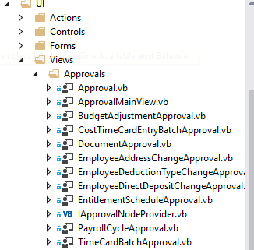
Document approvals use the DocumentApprovalOpenItems view.
The columns that are included on the Document Approval UI grid are predefined to be Document ID1, ID2, ID3, Document Date, Document Type, Batch, Approver, Approver Comments, TextColumn1, and TextColumn2.
TextColumn1 and TextColumn2 are the document header GLCostDocumentReference1 and GLCostDocumentReference2.
The following is from Empower > EM > Documents > Headers> DocumentHeader.
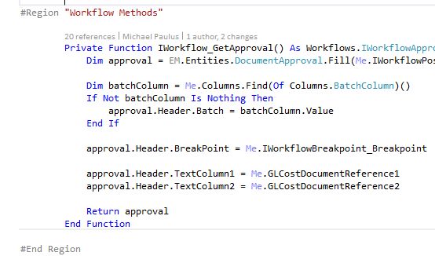
The labels for TextColumn1 and TextColumn2 are stored in default_workflows.
This is the UI used by documents.
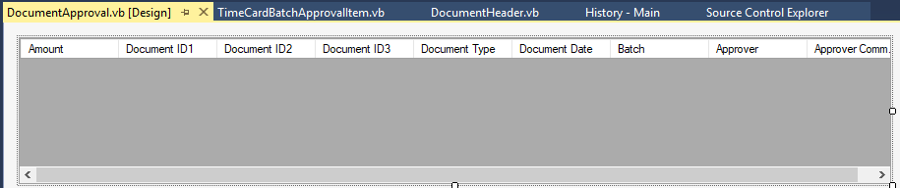

Entity approvals use individual class views and UI. In the classes we make the text columns invisible if we don’t want to use them. However, if leave the text columns visible but don’t give the text columns a heading in default_workflows and workflows, the text columns appear on the UI as narrow columns but are empty.
The following is from Empower > EM > Views > TimeCardBatchApprovalOpenItems
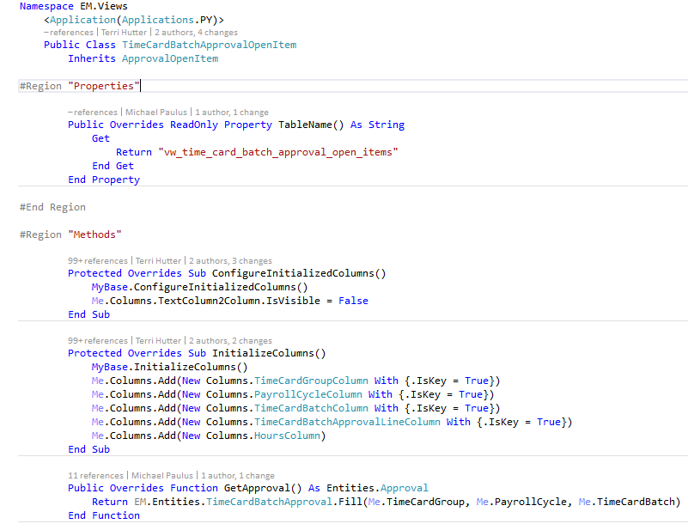
The following is in Empower.Windows > UI > Views > Approvals and is used on Empower.Windows > UI > Views TimeCardBatchApprovalView.vb.
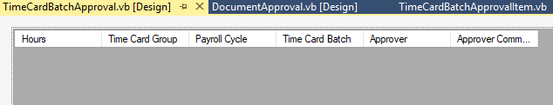

Document.vb
has a property on it called WorkflowApproveOnSave. A document is approved when it is saved if workflow says it should be or if a programmer has manually set DocumentHeader.Approved by calling subroutine SetApproved on DocumentHeader.vb.
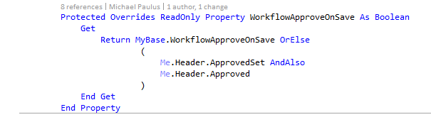
Table.vb
has properties on it related to Workflow.
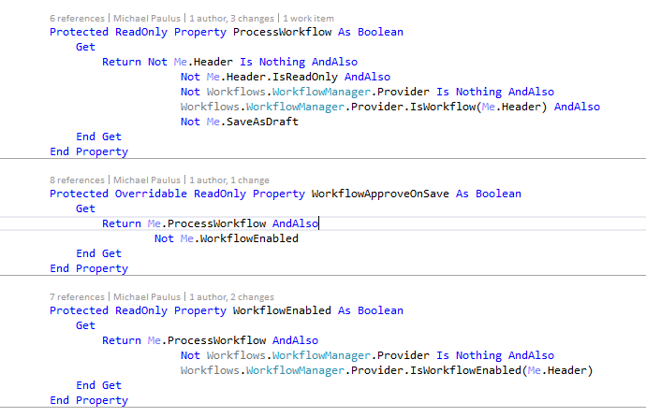

When the document header read only Approved column value is set by calling SetApproved on DocumentHeader.vb, a Boolean ApprovedSet is also set so that the code knows the Approved value was manually set, as opposed to set by workflow.
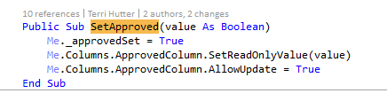
Several documents call subroutine SetApproved in order to override the False value that would normally be returned by Workflow.
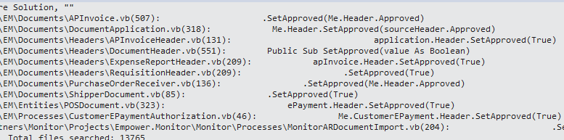
This is from ExpenseReportHeader.vb. When an Expense Report is approved and creates an AP invoice, Approved is set to True on the AP Invoice so Workflow is ignored.
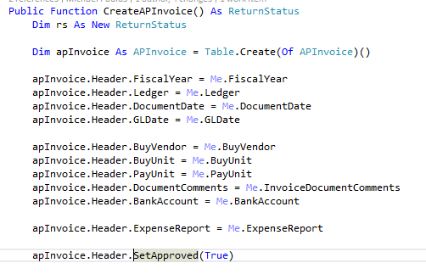

This is from Table.vb. When saving, if the document header hasn’t been manually approved and there is workflow, Empower calls ValidateApproval.
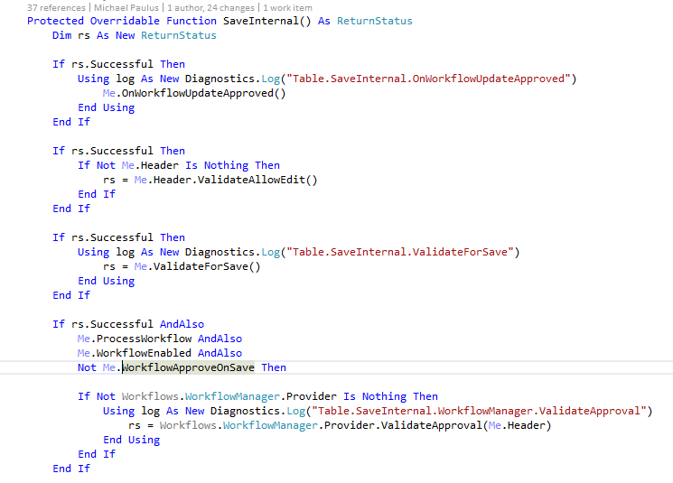

This is also from Table.vb.
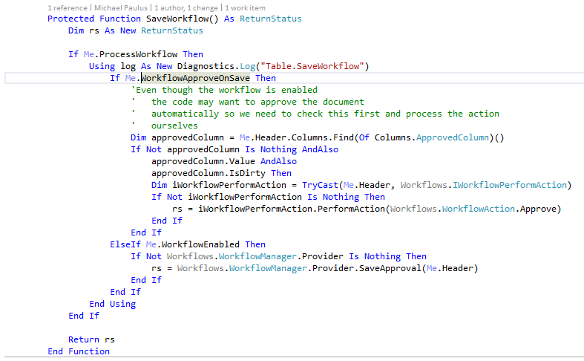
This is also from Table.vb
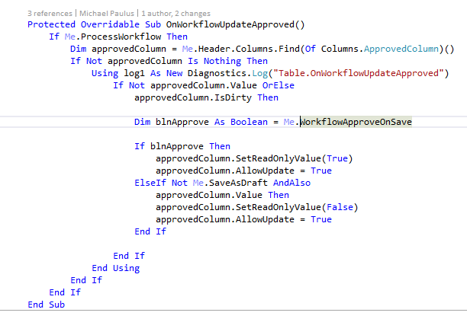

This is from APInvoices.vb. I added the code for CAPEX because Empire always wants CAPEX invoices approved. Not sure if this is the right place to add it.
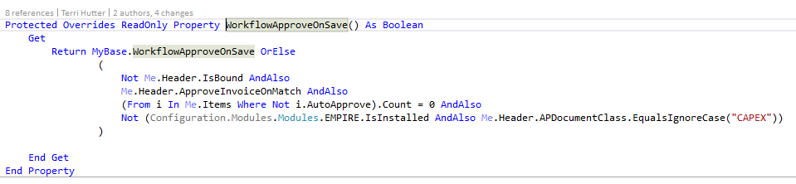
This is from PurchaseOrderApplications.vb. Not sure of its significance.
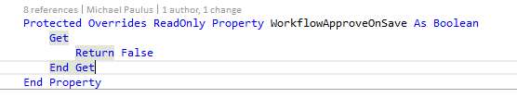

This is from BaseWorkflowProvider.vb.

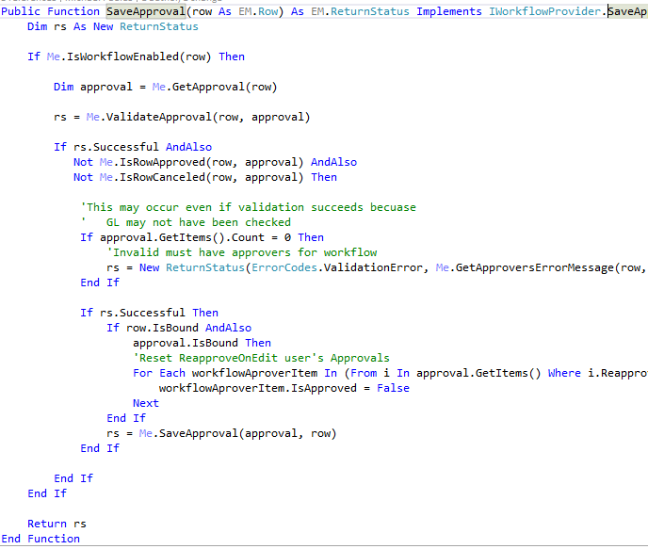
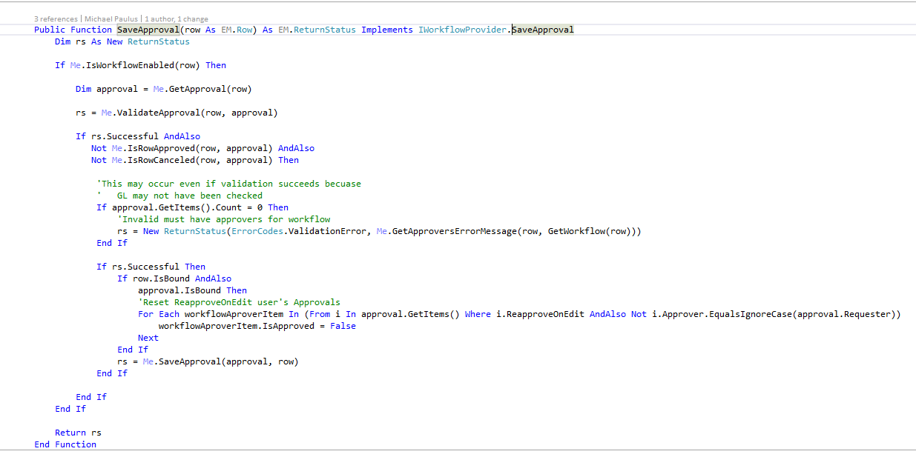

This is from ApprovalHeader. The Requester on an approval is set to the current user. When the document is approved, the current user gets an email saying it’s been approved.

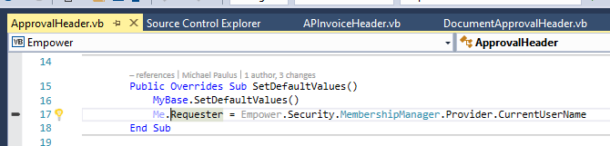

This is from BaseWorkFlowProvider function PerformWorkflowAction and is what updates the GL date when a document is approved and is in a closed period.
